Little Goose Dam Juvenile Fish Transportation
Collection Raceway Gas Bubble Trauma (GBT) Monitoring Plan

Introduction
Some of the information below was derived from TDG monitoring reports submitted to regional fish managers for transport seasons 2019 and 2020, written by Eric Hockersmith and Darren Pecora.

The U.S. Army Corps of Engineers (USACE) juvenile fish transport program collects smolts passing through the juvenile bypass systems (JBS) at Lower Granite, Little Goose and Lower Monumental dams and transports them via barge to below Bonneville Dam during the spring. Fish are collected and either held in raceways or direct loaded into a transport barge. Holding times before being transported are up to 48-hours dependent on when fish enter holding facilities. Holding water at juvenile fish facilities (JFF) is collected by dewatering a portion of bypass water from the Project forebay.

Beginning in 2018, the spring spill program underwent significant changes, increasing the amount of managed spill throughout the lower Snake and Columbia rivers. Pursuant to the 2018 injunctive order, Fish Operations Plan, Biological Opinion and eventually stay order, managed spill has increased from 120% total dissolved gas (TDG) to 125%, as measured in the tailwater.

TDG supersaturation can cause gas bubble disease (GBD) that can lead to physical injury or mortality. GBD severity is a function of TDG exposure level and duration with higher concentrations and increased duration of exposure causing higher severity (Weitkamp and Katz 1980). GBD signs and effects can be reduced or delayed with increased depth such as when fish sound. McGrath et al. (2006) reported that when compensating water depth is available, TDG levels up to 120% for short-term periods do not produce significant effects on juvenile or adult salmonids. In general, 10% TDG compensation occurs with each 1 meter in depth (Maynard 2008). Thus for 120% TDG at the surface, effective TDG would be 110% at 1 m deep and 100% at 2 m, etc.

The fish transport collection raceways are 1.5 m (5 feet deep), providing little opportunity for depth compensation. Tiffan et al. (2009) hypothesized that added stressors such as collection and handling combined with exposure to relatively low TDG levels (cyclic daily TDG swings from 102% to 109%) resulted in acute mortality for subyearling Chinook salmon held for less than 48 h at depths < 1m. Mesa et al. (2000) found that yearling Chinook salmon held in 120% TDG water had 20% mortality within 40 to 120 h and juvenile steelhead within 20 to 35 h. At 130% TDG, 20% mortality occurred in 3 to 6 h for yearling Chinook salmon and 5 to 7 h for juvenile steelhead. They did not observe any mortality for fish held 22 days when TDG was 110%. During 2019, TDG was below 110% in the barge fish holds and raceways, except at LGS raceways where TDG exceeded 110% approximately 82% of the time.

The USACE has not directly observed increased mortality related to GBD for fish collected and held in raceways or during fish transportation, however, delayed effects may be occurring particularly for fish held in the raceways and transported from LGS. Indirect mortality related to GBD can result in increased vulnerability to predation (Mesa and Warren 1997) and susceptibility to disease (Weiland et al. 1999). The relationships between indirect effects of long term chronic exposure to elevated TDG such as increased stress, susceptibility to disease, reduced growth, vulnerability to predation, or delayed mortality are poorly understood (McGrath et al.,2006).

In 2019 and 2020, USACE began monitoring TDG in transport barges and raceways. During these investigations, we quickly determined that TDG in raceways at Lower Granite Dam was not an issue as incoming water was unlikely to exceed 110% TDG and rarely exceeded 105%. These efforts also allowed us to determine that raceway TDG at Lower Monumental Dam rarely exceeds 110% for extended periods. This is because an orifice plate in the 36” water supply just upstream of the raceway headbox reduces (degasses) TDG levels of the supply water. The Little Goose raceway water is supplied by a 24” line and does not have an orifice plate to provide similar degassing capability. An assessment in 2019 of the Little Goose 24” raceway supply found that adding an orifice plate upstream of the raceway headbox would reduce the water volume below the amount needed to operate the holding facility at full capacity. From observations made in 2019 and 2020, we have found that TDG in the LGS raceways can exceed 110% when forebay TDG exceeds approximately 114% (Table 1; Figure 1). Using the relationship shown in Figure 1, we can estimate that the percent of time that TDG in raceways at LGS was equal to or greater than 110% has ranged from 4% to as high as 95% during April, May, and June over the last five years (Table 2).

Options to reduce Little Goose raceway TDG levels include operational and structural modifications. Direct loading fish to transport barges rather than temporarily holding in raceways would reduce exposure to elevated TDG because the barge water supply pumps keep the barge hold TDG below 110%. However, direct loading operations are dependent on debris amounts due to constriction in direct loading hoses and flumes. Additionally, holding times vary depending on transport frequency throughout the transport season.

USACE will continue to monitor TDG levels in transport barges and raceways at Little Goose and Lower Monumental dams. Additionally, USACE would like to examine a small number of juvenile salmonids held in transport raceways at Little Goose Dam to monitor for signs of GBD.

Study Plan
Objective: Evaluate if juvenile salmonids held in raceways at Little Goose Dam experience symptoms of GBT when river TDG is ≥ 125%?
We intend to sample 50-100 juvenile salmonids every-other-week that are held in transport raceways at Little Goose Dam during spring spill season for symptoms of GBD, April 3 through June 20. Numerous criteria would need to be met in order for sampling to occur.
Criteria 1 - Sampling would only occur when river flow is high enough to achieve 125% TDG spill, approximately 119% TDG measured in the tailwater of Lower Granite Dam (Figure 2). This objective may be challenging during some years and thus funding a research study may not be the most cost effective and may not provide appropriate biological evidence for all years.
Criteria 2 – Sampling would only occur if juvenile salmonids were held in raceways for an extended period of time, or during every-other-day barge transport. During daily transport, fish that are not sampled for the Smolt Monitoring Program (SMP) may only be held in a raceway for a few hours. During every-other-day transport, fish could be held in a raceway for approximately 24-hours.
Criteria 3 – Sampling would occur on non-transport days at a time that applicable staff are available.
When criteria are met, sample 25-50 juvenile salmonids from applicable raceway for each separated size group (small/large), or 50-100 fish total. Sampling goal would be to conduct sampling every-other-week during spring spill when all criteria are met utilizing current FPC Gas Bubble Trauma Monitoring Protocol for examination and ranking methods.

Table 1. Predicted raceway TDG at Little Goose Dam for a given TDG in the forebay based on regression equations generated from Figure 1, below.
Forebay TDG (%) | Predicted Little Goose Dam  Raceway TDG (%)
110 | 107.7
111 | 108.3
112 | 108.9
113 | 109.5
114 | 110.1
115 | 110.7
116 | 111.3
117 | 111.9
118 | 112.5
119 | 113.0
120 | 113.6
121 | 114.2
122 | 114.8
123 | 115.4
124 | 116.0
125 | 116.6
126 | 117.2
127 | 117.8
128 | 118.3
129 | 118.9
130 | 119.5

Figure 1. Relationship between forebay and raceway TDG levels at Little Goose Dam during spring spill, 2019 and 2020.

Table 2. Average and maximum TDG measured in the forebay at Little Goose Dam and average and maximum TDG predicted to occur in the Little Goose Dam raceways along with proportion of hourly raceway TDG predicted to be equal to or greater than 110%, April 3 through June 20.
Year | Month | Forebay |  | Estimated Raceway
Year | Month | Average | Max | Average | Max | ≥ 110%
2022 | April | 108.0 | 114.5 | 106.6 | 110.4 | 4%
2022 | May | 114.7 | 120.4 | 110.5 | 113.9 | 58%
2022 | June | 117.9 | 122.5 | 112.4 | 115.1 | 95%
2021 | April | 109.6 | 116.0 | 107.5 | 111.2 | 9%
2021 | May | 114.4 | 121.0 | 110.3 | 114.2 | 49%
2021 | June | 114.8 | 120.5 | 110.6 | 113.9 | 50%
2020 | April | 110.5 | 116.5 | 108.0 | 111.5 | 33%
2020 | May | 116.8 | 123.3 | 111.8 | 115.5 | 90%
2020 | June | 116.6 | 123.2 | 111.6 | 115.5 | 84%
2019 | April | 112.9 | 120.0 | 109.5 | 113.6 | 46%
2019 | May | 114.9 | 118.8 | 110.5 | 112.9 | 76%
2019 | June | 114.8 | 120.0 | 110.5 | 113.6 | 70%
2018 | April | 113.5 | 121.1 | 109.8 | 114.3 | 56%
2018 | May | 113.7 | 120.1 | 109.9 | 113.7 | 51%
2018 | June | 112.5 | 119.3 | 109.2 | 113.2 | 26%

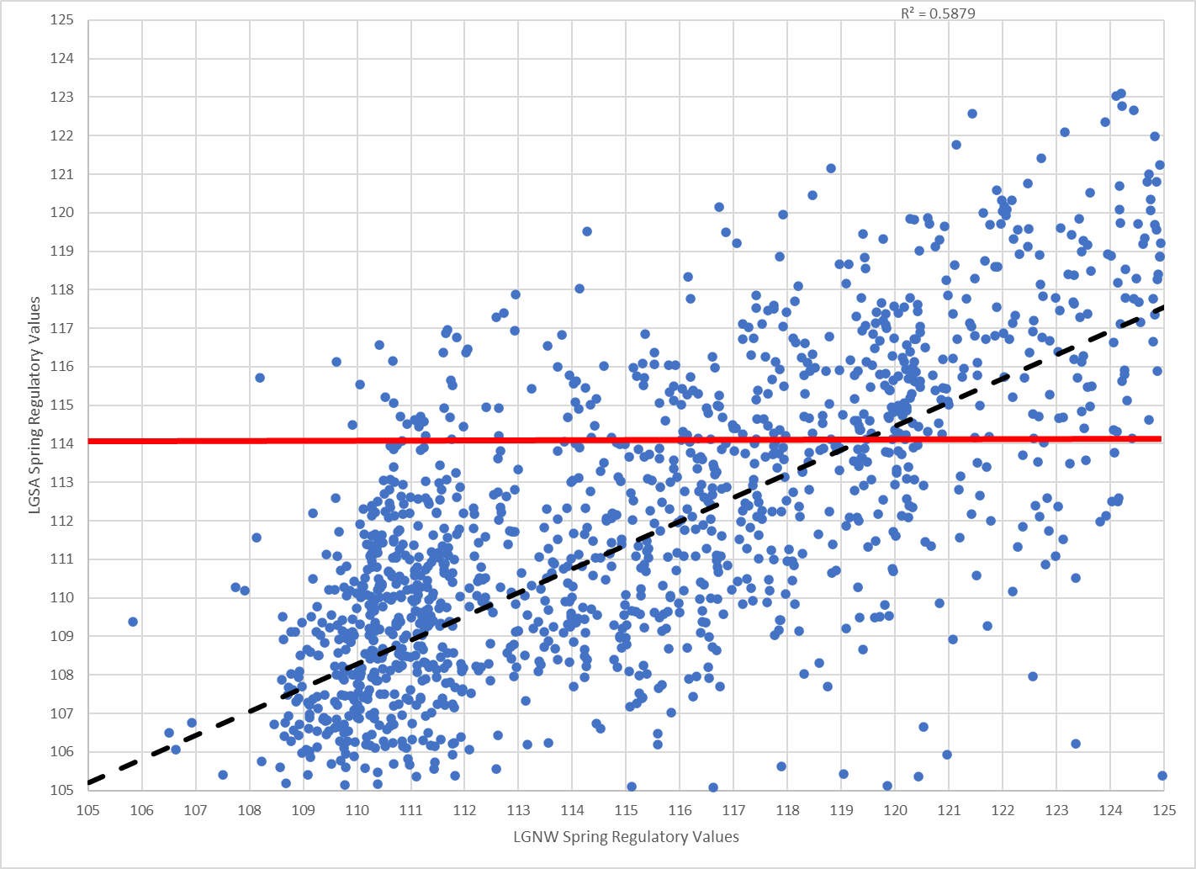
Figure 2. Scatter plot regression comparing Lower Granite Dam tailwater (LGNW) to Little Goose Dam forebay (LGSA) percent TDG. Red horizontal line inidicates 114% TDG in Little Goose Dam forebay.
References
Eaton, A. D., Clesceri, L. S., Greenberg, A. E., & Franson, M. A. H. 1998. Standard methods for the examination of water and wastewater. 20th ed. 1998. Washington, DC: American Public Health Association.
Flexible Spill Agreement. 2018. available at: https://www.bpa.gov/efw/FishWildlife/SpillOperationAgreement/doc/ECF-2298_Spill-Notice-and-Agreement.pdf
HACH. 2006. Hydrolab DS5X, DS5, and MS5Water Quality Multiprobes User Manual: February 2006, Edition 3. Available at: https://s.campbellsci.com/documents/ca/manuals/series_5_man.pdf
Maynard, C. 2008. Evaluation of Total Dissolved Gas Criteria (TDG) Biological Effects Research: A literature review. WA State Department of Ecology Publication 08-10-059.
McGrath, K. E., E.M. Dawley, and D. R. Geist. 2006. Total Dissolved Gas Effects on Fishes of the Lower Columbia River. PNNL-15525. Report to U.S. Army Corps of Engineers Portland District, Portland, Oregon Contract DE-AC05-76RL01830. 40 p.
Mesa M. G., L. K. Weiland, and A. G. Maule. (2000). Progression and Severity of Gas Bubble Trauma in Juvenile Salmonids. Transactions of the American Fisheries Society, 129:174-185.

Mesa, M. G., and J. J. Warren. 1997. Predator avoidance ability of juvenile Chinook Salmon subjected to sublethal exposures of gas supersaturated water. Canadian Journal of Fisheries and Aquatic Science 54:757–764.

Tiffan, K. F., W. P. Connor, B. J. Bellegraph, and R. A. Buchanan. 2009. Snake River fall Chinook salmon life history investigations annual report 2008. Report to Bonneville Power Administration, Portland, OR. Project number 200203200.

Weiland, L. K., M. G. Mesa, and A. G. Maule. 1999. Influence of infection with Renibacterium salmoninarum on susceptibility of juvenile spring Chinook Salmon to gas bubble trauma. Journal of Aquatic Animal Health 11:123–129.

Weitkamp D.E. and Katz M. (1980). A review of dissolved gas supersaturation literature. Transactions of the American Fisheries Society109, 659-702.

